Create a LAN

Local area networks

The term local area network (LAN) refers to a local network, or a group of interconnected local networks that are under the same administratice control. In the early days of networking, LANs were defined as small networks that existed in a single physical location.

Althrough LANs can be a single local network installed in a home or small office, the definition of LAN has evolved to include interconnected local networks consisting of many hundreds of hosts, installed in multiple buildings and locations.

**The inportant thing to remember is that**

All the local networks within a LAN are under one administrative control.

They typically use Ethernet or wireless protocols and support high data rates

Local and remote network segments

**Within a LAN, it is possible to place all hosts on a single local network or divide them up between multiple networks connected by a distribution layer device.**

How this placement is determined depends on desired results

- ***all hosts in one local segment***

Placing all hosts on a single local network allows them to be seen by all other hosts

In a simple network design, it may be beneficial to keep all hosts within a single local network. However, as networks grow in size, increased traffic will decrease network performance and speed. In this case, it may be beneficial to move some hosts onto a remote network.

**Advantages**:

- **appropriate for simple networks**

- **less complexity and lower network cost**

- **allows devices to be “seen”**

- **faster data transfer**

- **ease of device access**

**Disadvantages**:

- **all hosts are in one broadcast domain which causes more traffic, slownes**

- **harder to implement QoS**

- **harder to implement security**

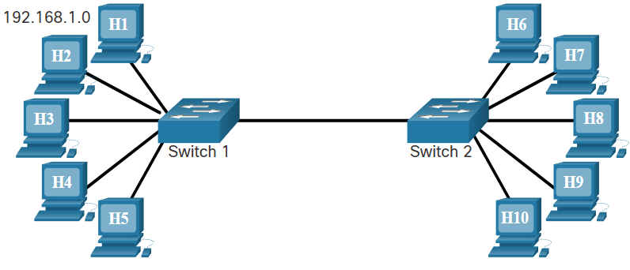

- ***Hosts on a remote segment***

**Placing additional hosts on a remote network will decrease the impact of traffic demands.** However, hosts on one network will not be able to communicate with hosts on the other network without the use of routing.

Routers increase the complexity of the network config and can introduce latency, or time delay on sent msges

**Advantages**:

- **more appropriate for larger, more complex networks**

- **splits up broadcast domains and decreases traffic**

- **can improve performance on each segment**

- **makes the machines invisible to those on other local networks**

- **can provide increased security**

- **can improve network organization**

**Disadvantages**:

- **requires the use of routing**

- **router can slow traffic between segments**

- **more complexity and expense**

